Moodle Support for Students
It is important for instructors to be aware of the many resources available to students that can assist them in using Moodle. If you are looking for assistance for your students, there are online resources and Moodle support personnel available.

Contents
- Moodle Help resources within the Moodle Environment:
- Dashboard
- Moodle Tab
- Accessing services for students to get support in Moodle:
- Computer Commons
- Booking appointments with a Moodle Advisor for Students
Moodle Help Resources within the Moodle Environment
Dashboard
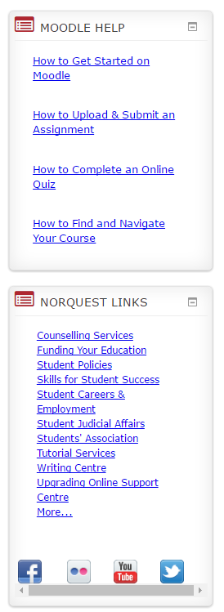
Moodle Help and NorQuest Links Side Blocks on Student Dashboard
Excellent links to resources may be found on the students’ NorQuest Moodle Dashboard. Moodle Help assists students in being successful with Moodle and NorQuest Links provide information on how to be successful as a NorQuest student and lists support services available. Below are the screen shots of available links, which are followed by links pertaining to Moodle.



Links for student resources for Moodle:
How to Get Started on Moodle
How to Upload & Submit an Assignment
How to Complete an Online Quiz
How to Find and Navigate Your Course
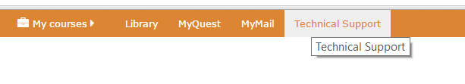
Technical Support Moodle Tab on all Moodle Pages including the Dashboard

The Technical support tab links students to a Moodle Support page where they will find documentation on how to log in to Moodle, as well as other resources. There is a link to a Moodle Manual for Students. [1] This covers an array of topics from navigating Moodle to submitting assignments to netiquette. This is a great resource, which instructors may want to link to in their course.
If students need additional support beyond instructor and online resources, they may also Book a Moodle Help Appointment. [2] Once this link is selected, another page opens where students may reserve a private consultation with a Moodle Advisor. Students may also ask their questions through Moodle Chat. If students require a Moodle Password reset, they are directed to computercommons@norquest.ca.
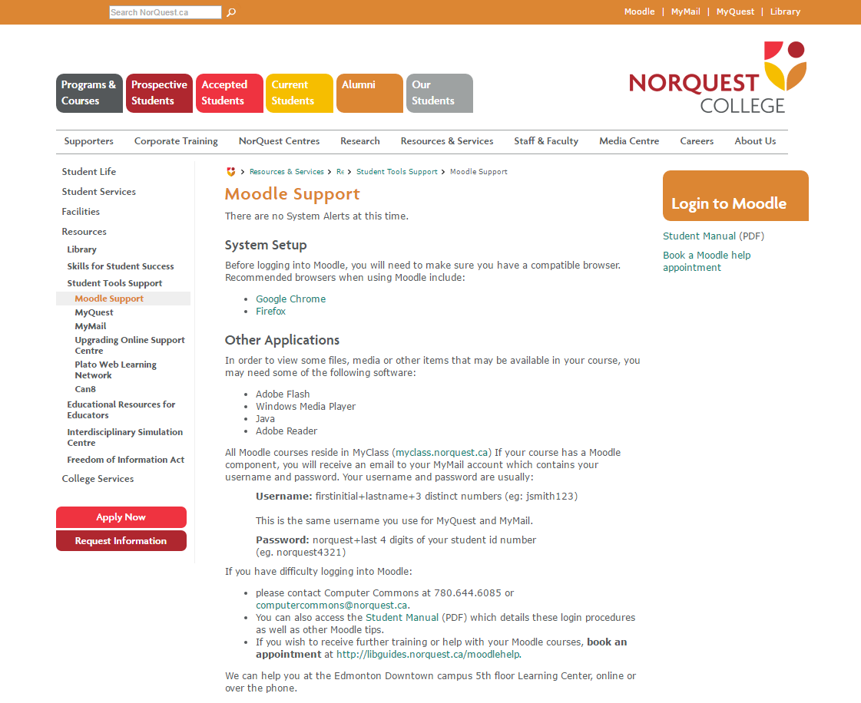

1
2

1
1

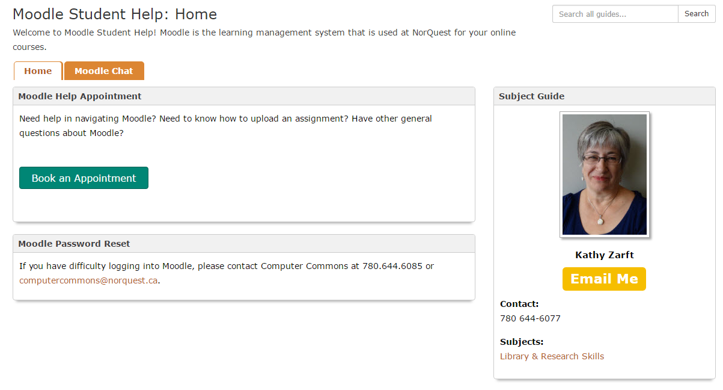

Accessing Services for Students to get Support in Moodle
Computer Commons
Computer Commons may be reached by email computercommons@norquest.ca. Computer Commons is located on the 5th floor of the A Building downtown in back of the Library.

Booking Appointments with a Moodle Advisor for Students
A student may follow the prompts in the Technical Help tab within the Moodle environment, or they may use the url to come to the NorQuest Library Moodle Student Support Home Page. http://libguides.norquest.ca/moodlehelp

For more information about services for your students contact Computer Commons.

